# CUTLER Testing Tracker

**All nodes have these below:**

# Baseline configuration of the CUTLER VMs

The following installation/configuration steps were applied to the c1, c2, c3, c4 baseline VM images:

- sudo apt update

- sudo apt upgrade

Base packages/tools:

- sudo apt install net-tools

- sudo apt install ifupdown

- sudo mkdir /etc/dhcp3

- sudo apt install default-jdk

- sudo apt install python3.6

- sudo apt install python3-pip

- sudo apt install python3-pandas

- sudo apt install python3-bs4

- sudo apt install python3-dateutil

- sudo apt install python3-requests

- sudo apt install python-pip

- apt install openjdk-11-jdk-headless

- sudo apt-get install nmap

- pip install pyexcel-ezodf

- sudo apt install curl

- pip3 install -U selenium

IPS:

- sudo apt install fail2ban

- sudo cp /etc/fail2ban/jail.conf /etc/fail2ban/jail.local

- edit the .local file

- "5m" ban time

- uncomment "enabled = true"

- everything else default

- sudo systemctl restart fail2ban

Add non-root user:

- sudo adduser cutleruser/cutler

Google Chrome:

- wget -q -O - https://dl-ssl.google.com/linux/linux_signing_key.pub | sudo apt-key add -

- sudo sh -c 'echo "deb [arch=amd64] http://dl.google.com/linux/chrome/deb/ stable main" >> /etc/apt/sources.list.d/google.list'

- sudo apt update

- sudo apt install google-chrome-stable

- wget https://chromedriver.storage.googleapis.com/73.0.3683.68/chromedriver_linux64.zip

- unzip chromedriver_linux64.zip

- sudo mv chromedriver /usr/bin/

- chmod +x /usr/bin/chromedriver

GeckoDriver:

- wget https://github.com/mozilla/geckodriver/releases/download/v0.24.0/geckodriver-v0.24.0-linux64.tar.gz

- tar -xvf geckodriver-v0.24.0-linux64.tar.gz

- sudo mv geckodriver /bin

Crawlers (for ES nodes):

- pip3 install virtualenv

- sudo add-apt-repository ppa:alex-p/tesseract-ocr

- sudo apt update

- sudo apt install tesseract-ocr

- sudo apt install python3-xlrd

- sudo apt install python3-openpyxl

node.js:

- curl -s -O https://deb.nodesource.com/node_10.x/pool/main/n/nodejs/nodejs_10.13.0-1nodesource1_amd64.deb

- sudo dpkg -i nodejs_10.13.0-1nodesource1_amd64.deb

Enable ssh server:

sudo apt update

sudo apt install openssh-server

sudo systemctl status ssh

# Testing in Pilot-2 Testbed

**Test Elastic Search**

Test to see if elastic cluster is formed correctly (no split brain, etc.) <http://(master_node_ip):9200/_cluster/state?pretty>

curl -X GET <http://(master_node_ip):9200/_cluster/health?pretty>

**ElasticSearch Master Node**

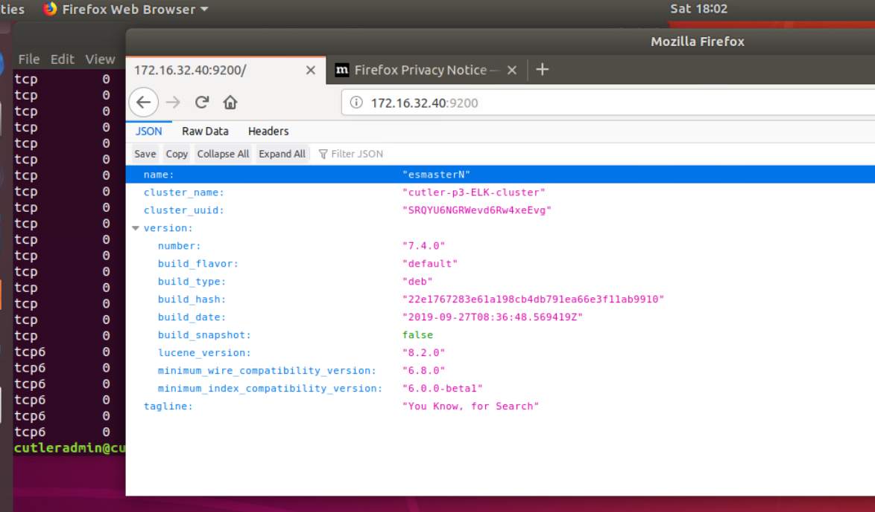

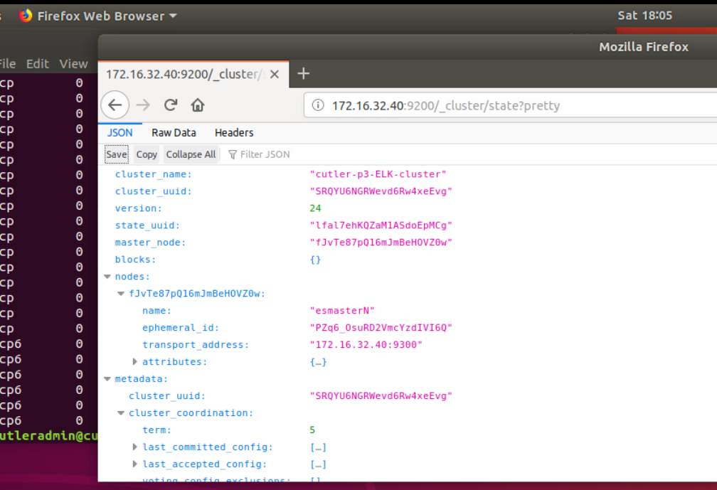

**Get node list:** curl -X GET http://172.16.32.40:9200/_nodes

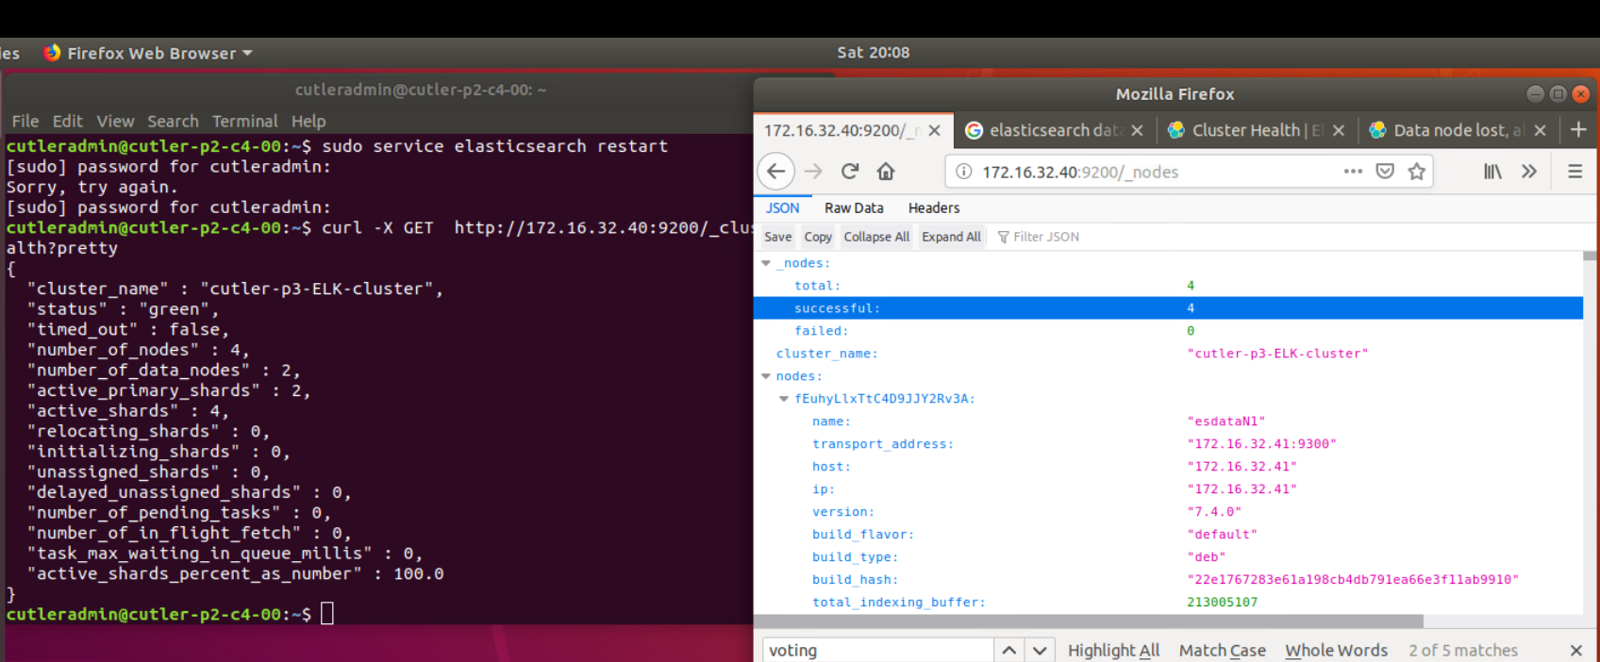

**Check log file:**

sudo nano /var/log/elasticsearch/cutler-p2-ELK-cluster.log

**Testing Apache:**

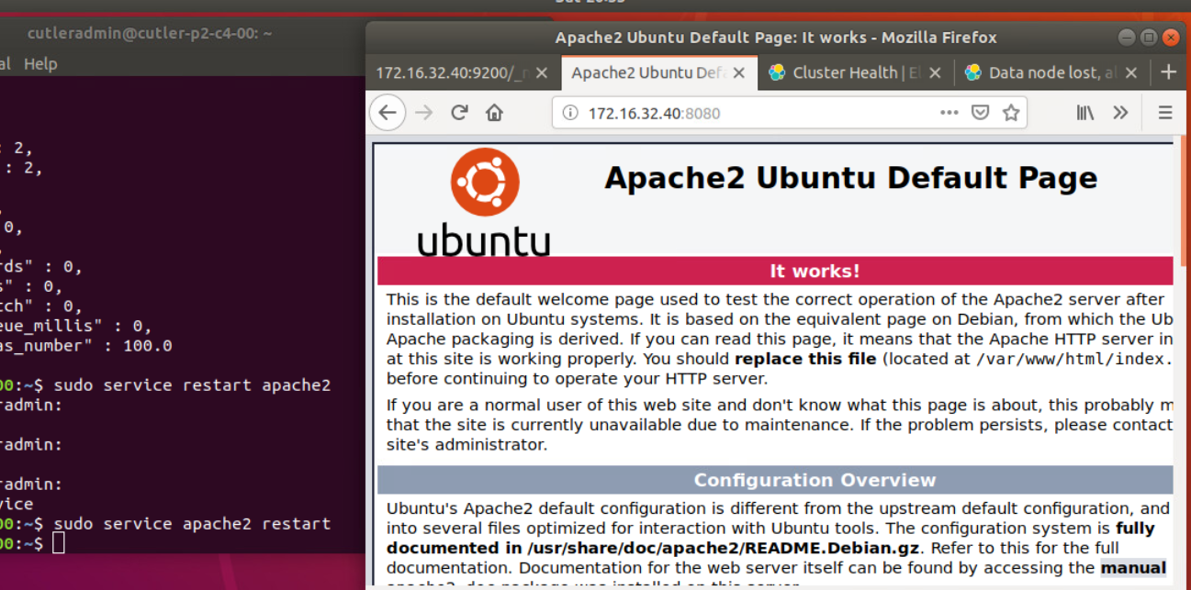

**Test Kafka Cluster:**

**Zookeeper:**

**+ Start zk:**

cd /opt/zookeeper/zk

sudo bin/zkServer.sh start-foreground

**Make sure all three zookeepers up and running and has correct leader election**

**Server.1:**





**Server.2: - LEADER**

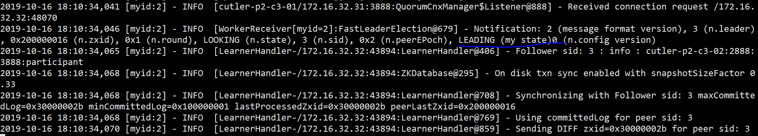

**Server.3:**

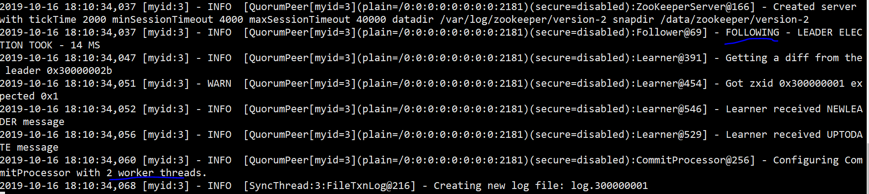

**Kafka:**

Ansible setting currently:

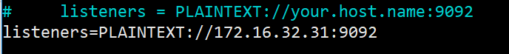

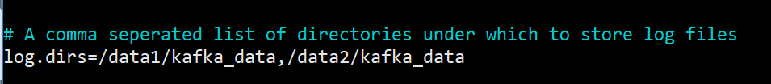

**+ Start the brokers** (or check if they’re started by default, should be from the ansible setting) (netstat -ant or check systemctl status -u kafka.service)

As in ansible: bin/kafka-server-start.sh -daemon config/server.properties

**+Test the installation:**

*bin/kafka-topics.sh --create --topic testingtopic --zookeeper localhost:2181 --partitions 3 --replication-factor 3*

partition allows how many brokers you want data to be split. As, we have 3 brokers, we can set this to 3.

replication factor allows how many copies of data you need. This is helpful when any broker down other brokers can handle the job.

**What we did:**

$ bin/kafka-topics.sh --create --topic test01 --zookeeper localhost:2181 --partitions 3 --replication-factor 3



$ bin/kafka-topics.sh --describe --topic test03 --zookeeper localhost:2181

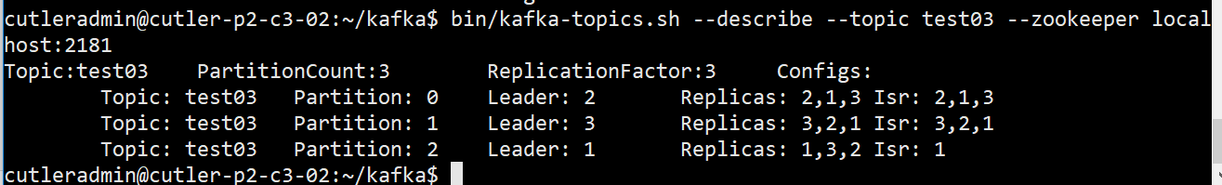

**What we did:**

$ bin/kafka-console-producer.sh --broker-list 172.16.32.30:9092,172.16.32.31:9092,172.16.32.32:9092 --topic topic03

$ bin/kafka-console-consumer.sh --bootstrap-server 172.16.32.33:9092 --topic topic03 --from-beginning

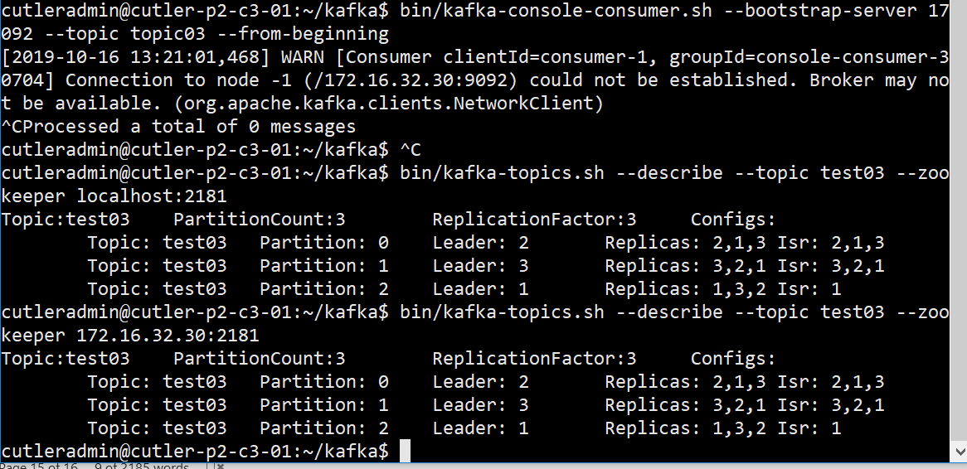

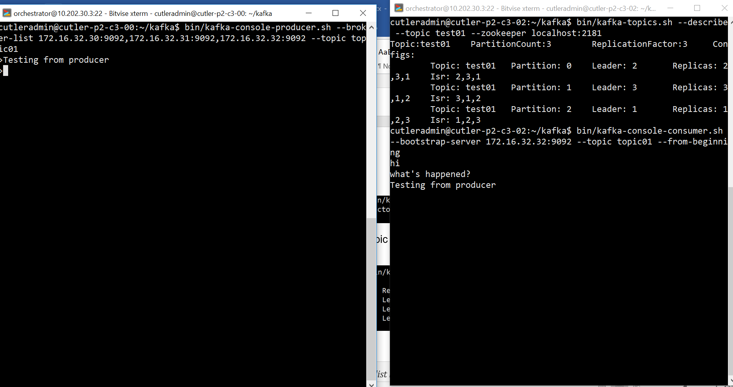

**Testing Hadoop Cluster:**

1. Starting the services:

* start-dfs.sh - Starts the Hadoop DFS daemons, the namenode and datanodes. Use this before start-mapred.sh
* stop-dfs.sh - Stops the Hadoop DFS daemons.
* start-mapred.sh - Starts the Hadoop Map/Reduce daemons, the jobtracker and tasktrackers.
* stop-mapred.sh - Stops the Hadoop Map/Reduce daemons.
* start-all.sh - Starts all Hadoop daemons, the namenode, datanodes, the jobtracker and tasktrackers. Deprecated; use start-dfs.sh then start-mapred.sh
* stop-all.sh - Stops all Hadoop daemons. Deprecated; use stop-mapred.sh then stop-dfs.sh
* Alternatively, use hadoop-daemon.sh and yarn-daemon.sh scripts to start the specific HDFS and YARN services respectively on each node.

For configuration of the memory allocation, refer to the below.

* How much memory can be allocated for YARN containers on a single node -> This value is configured in yarn-site.xml with yarn.nodemanager.resource.memory-mb.
* How much memory a single container can consume and the minimum memory allocation allowed. -> Those values are configured in yarn-site.xml with *yarn.scheduler.maximum-allocation-mb* and *yarn.scheduler.minimum-allocation-mb*.
* How much memory will be allocated to the ApplicationMaster. This is a constant value that should fit in the container maximum size. -> This is configured in mapred-site.xml with yarn.app.mapreduce.am.resource.mb.
* How much memory will be allocated to each map or reduce operation. This should be less than the maximum size. ->This is configured in mapred-site.xml with properties mapreduce.map.memory.mb and mapreduce.reduce.memory.mb.

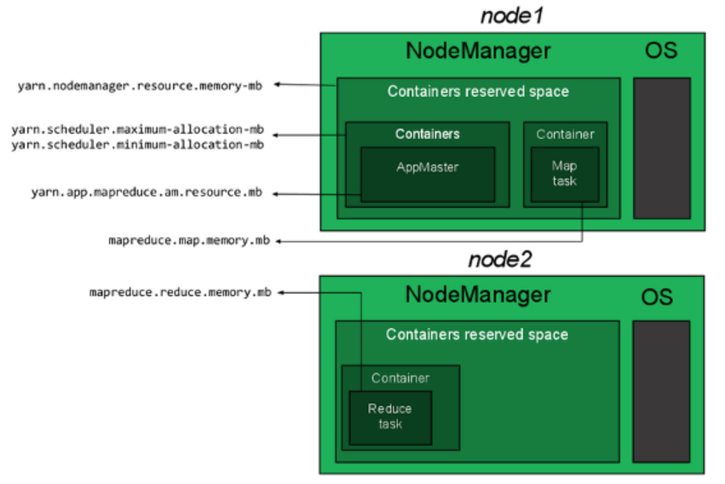

Current setting for 12GB: (could increase the nodemanager & maximum -> 10GB for 12GB core, or 14GB for 16GB core depending on the requirements of jobs)

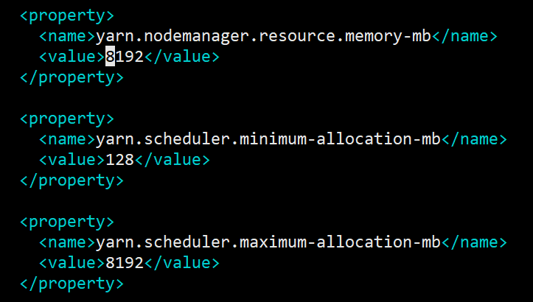

Open ports: 9866 (datanodes to masternode - The datanode server address and port for data transfer)

**Start and Stop HDFS:**

On the NameNode:

start-dfs.sh

start NameNode and SecondaryNameNode on namenode, and DataNode on datanodes in the workers config file.

On namenode:

21922 Jps

21603 NameNode

21787 SecondaryNameNode

And on datanode:

19728 DataNode

19819 Jps

To stop HDFS on master and worker nodes, run the following command from node-master:

stop-dfs.sh

**Monitor your HDFS Cluster**

You can get useful information about running your HDFS cluster with the hdfs dfsadmin command. Try for example:

hdfs dfsadmin -report

This will print information (e.g., capacity and usage) for all running DataNodes. To get the description of all available commands, type:

hdfs dfsadmin -help

You can also automatically use the friendlier web user interface. Point your browser to http://node-master-IP:9870, where node-master-IP is the IP address of your node-master, and you’ll get a user-friendly monitoring console.

1. Submit a job:
2. List all *hadoop*.jar

$ sudo find / -name "*hadoop*.jar" | grep example

1. Checking the job example:

$ hadoop jar /home/cutleradmin/hadoop-3.2.0/hadoop-3.2.0/share/hadoop/mapreduce/hadoop-mapreduce-examples-3.2.0.jar

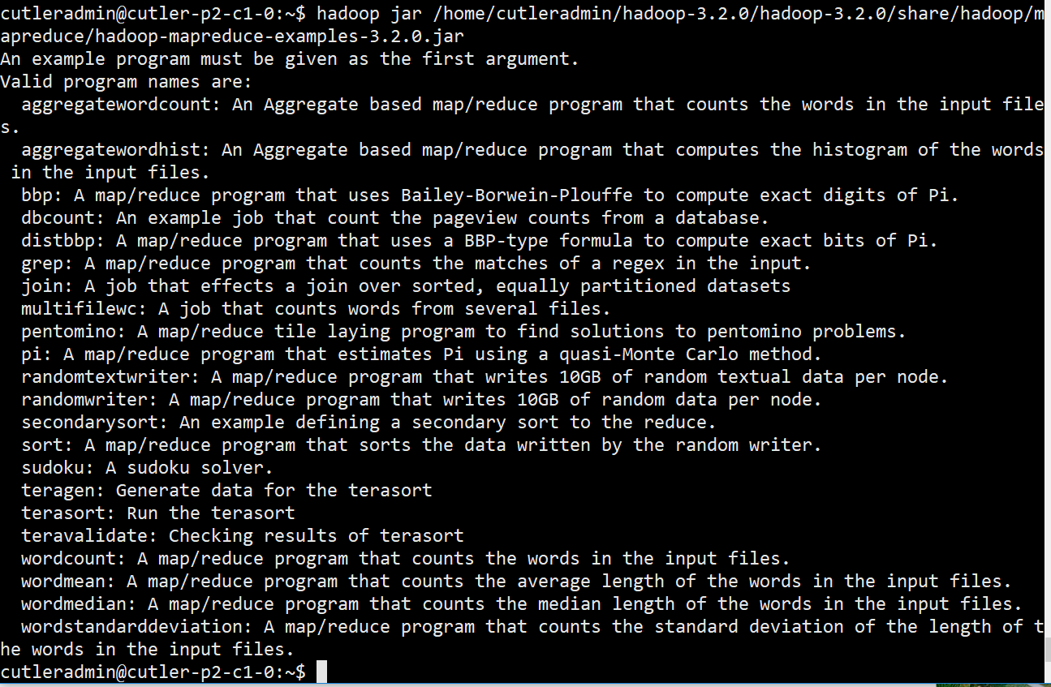

1. Submit a job

Estimate Pi, 100 mappers, 20 samples/mapper

$ hadoop jar /home/cutleradmin/hadoop-3.2.0/share/hadoop/mapreduce/hadoop-mapreduce-examples-3.2.0.jar pi 100 20

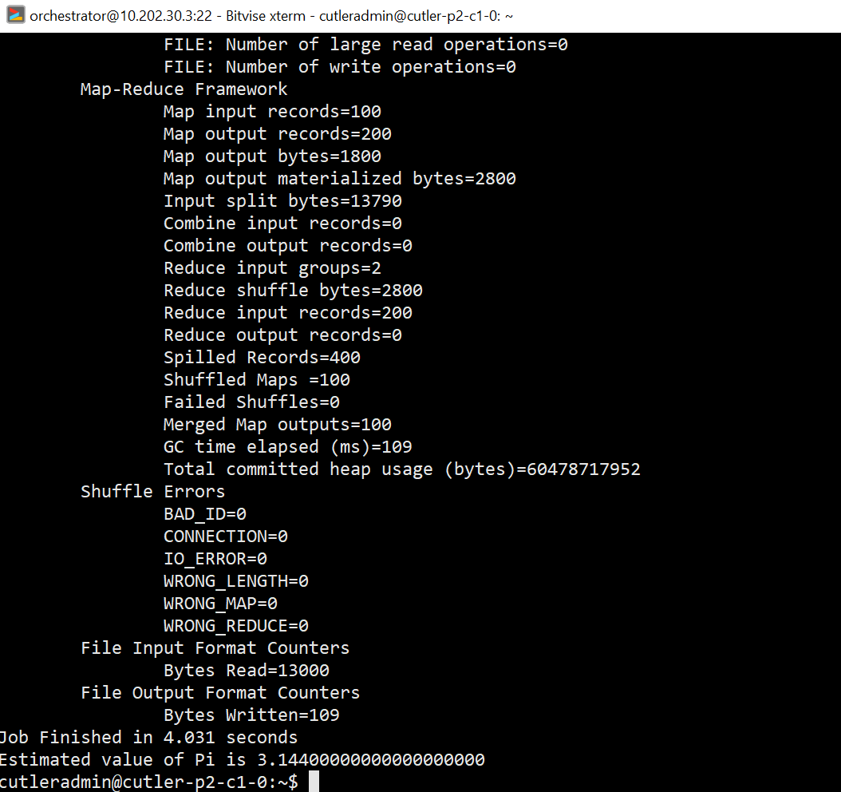

* Hadoop is working fine.

1. Monitoring

**Testing Yarn RM:**

Make sure you've started Yarn. Use this command to start it:

start-yarn.sh

Then use this command to verify that the Resource Manager is running:

jps

The output should look something like this:

17542 NameNode

17920 SecondaryNameNode

22064 Jps

17703 DataNode

18226 ResourceManager

18363 NodeManager

**Issues:**

Issue# Missing JAVA_HOME,

sudo nano /etc/profile.d/hadoop-env.sh -> updated

Export in /etc/hadoop/hadoop-env.sh

export JAVA_HOME=/usr/lib/jvm/<jdk folder>

echo $JAVA_HOME to see the path.

File: /home/cutleradmin/hadoop-3.2.0/hadoop-3.2.0/etc/hadoop/hadoop-env.sh

export JAVA_HOME=/usr/lib/jvm/java-11-openjdk-amd64/

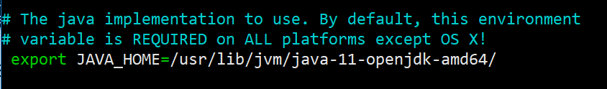

JPS (Java Virtual Machine Process Status Tool) is a command is used to check all the Hadoop daemons

After fixing the java home, issue:

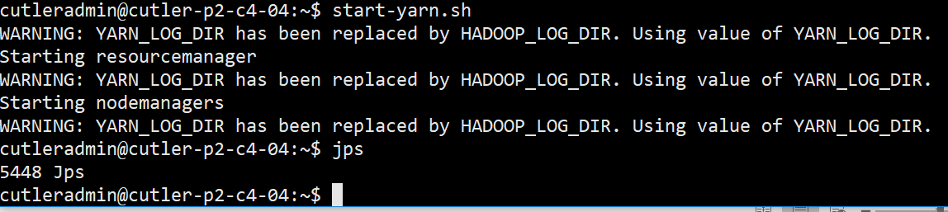

Workers are wrong-defined.

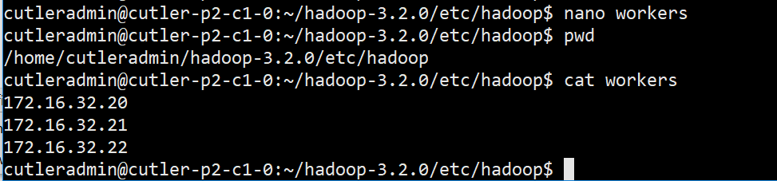

Downgrade to jvm 8:

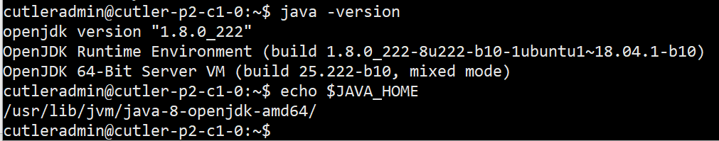

Added all hosts and IPs in the cluster

sudo nano /etc/hosts

172.16.32.10 cutler-p2-c1-0

172.16.32.20 cutler-p2-c2-0

172.16.32.21 cutler-p2-c2-1

172.16.32.22 cutler-p2-c2-2

172.16.32.44 cutler-p2-c4-4

After all fixes above, run start-all.sh on the namenode, then check status on each node, all correct:

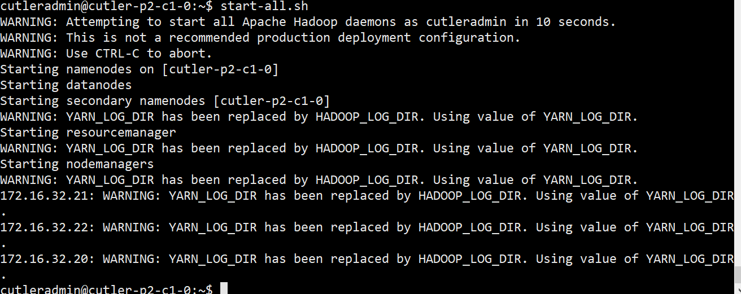

**Status: looks good**

NameNode:

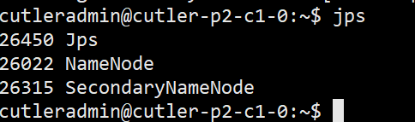

ResourceNode:

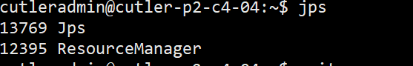

DataNode:

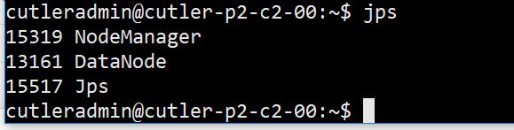

**Hadoop NameNode Web UI:**

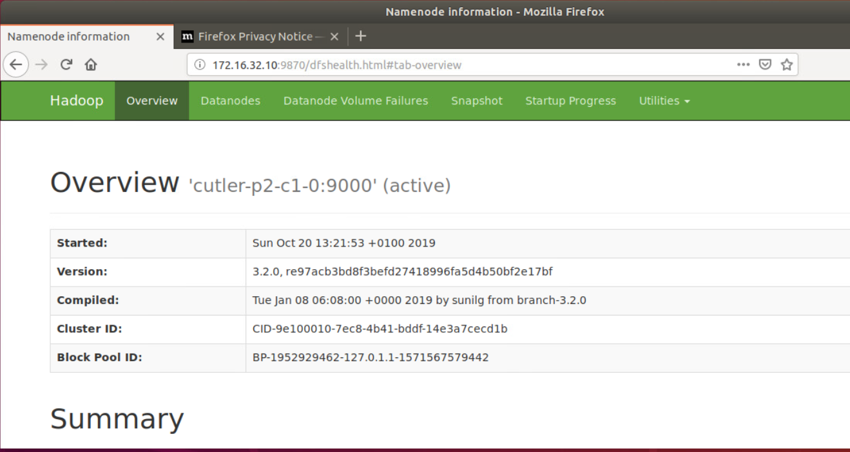

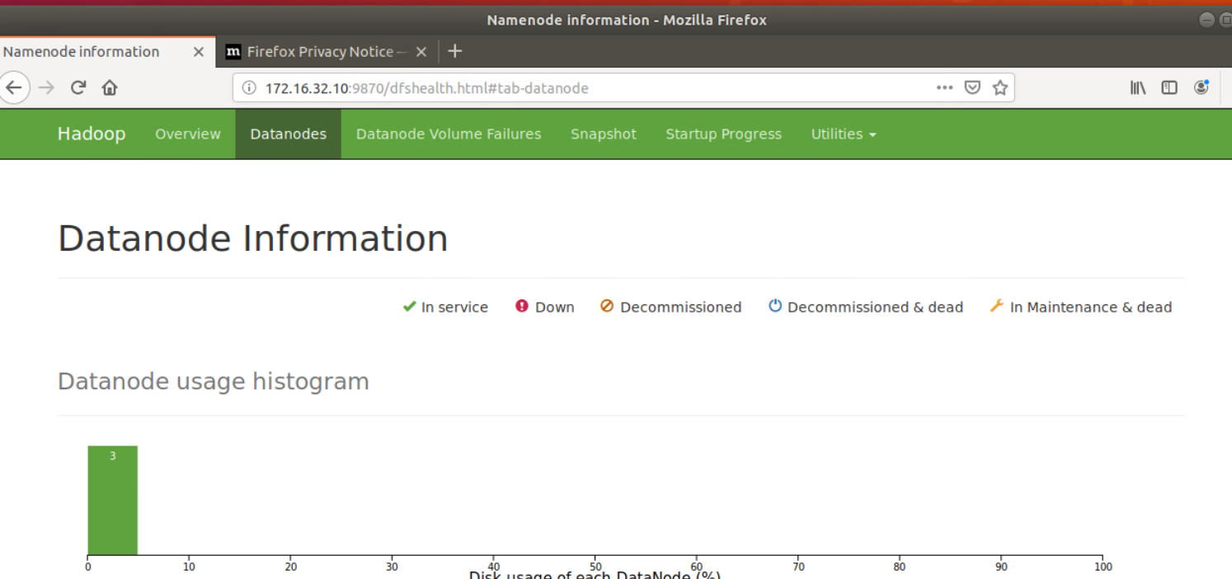

Resource Manager web UI:

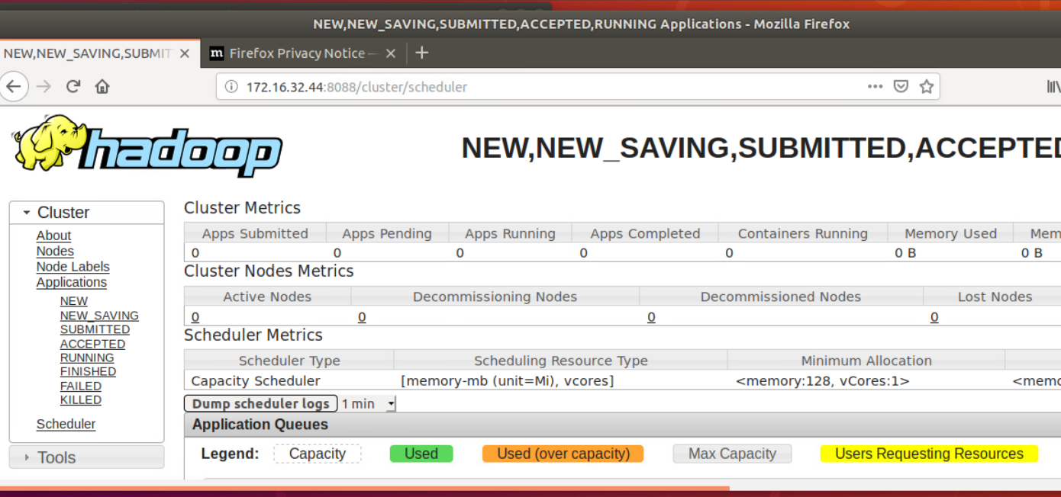

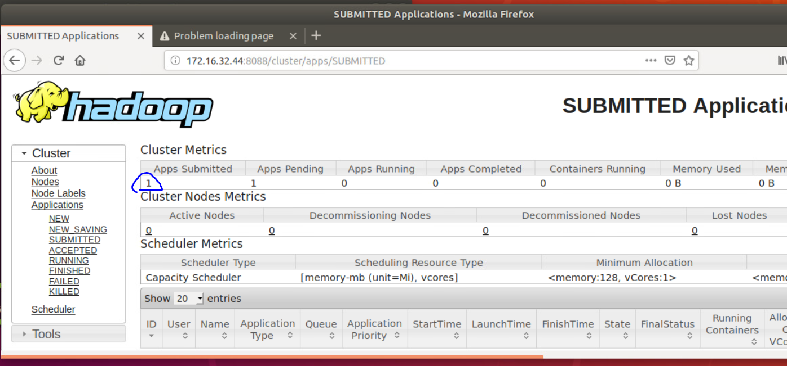

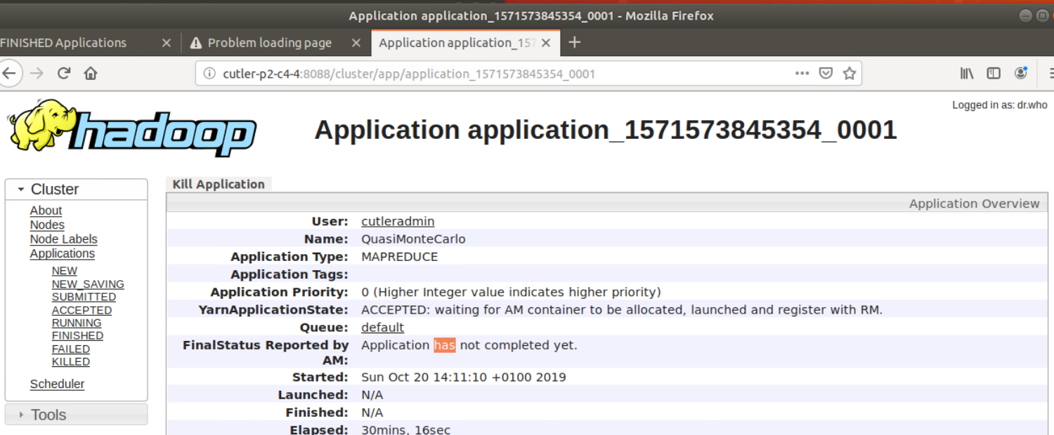

**Test Spark:**

sudo nano /etc/profile.d/spark.sh

export PATH=$PATH:/opt/spark/bin

export SPARK_HOME=/opt/spark

export HADOOP_CONF_DIR=$HADOOP_HOME/etc/hadoop

export LD_LIBRARY_PATH=$LD_LIBRARY_PATH:$HADOOP_HOME/hadoop/lib/native

export SPARK_DIST_CLASSPATH=$(hadoop classpath)

*# Passing a Hadoop configuration directory*

#export SPARK_DIST_CLASSPATH=**$(**hadoop --config /path/to/configs classpath**)**

sudo mv /opt/spark/conf/spark-defaults.conf.template /opt/spark/conf/spark-defaults.conf

sudo nano /opt/spark/conf/spark-defaults.conf

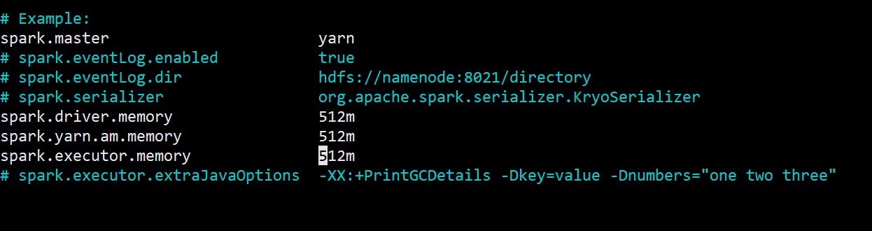

**Submitting a Spark job example:**

Run the sample Pi calculation, use the following command (at cutleradmin home directory):

$ spark-submit --deploy-mode client --class org.apache.spark.examples.SparkPi /opt/spark/examples/jars/spark-examples_2.11-2.4.3.jar

*--deploy-mode*, specifies which mode to use, *client* or *cluster*.

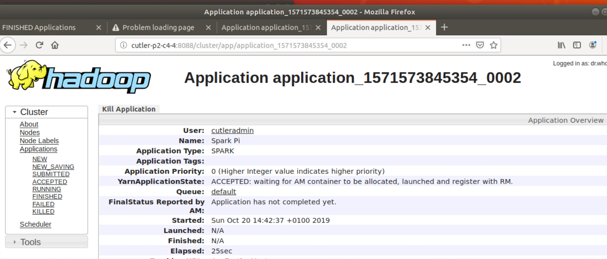

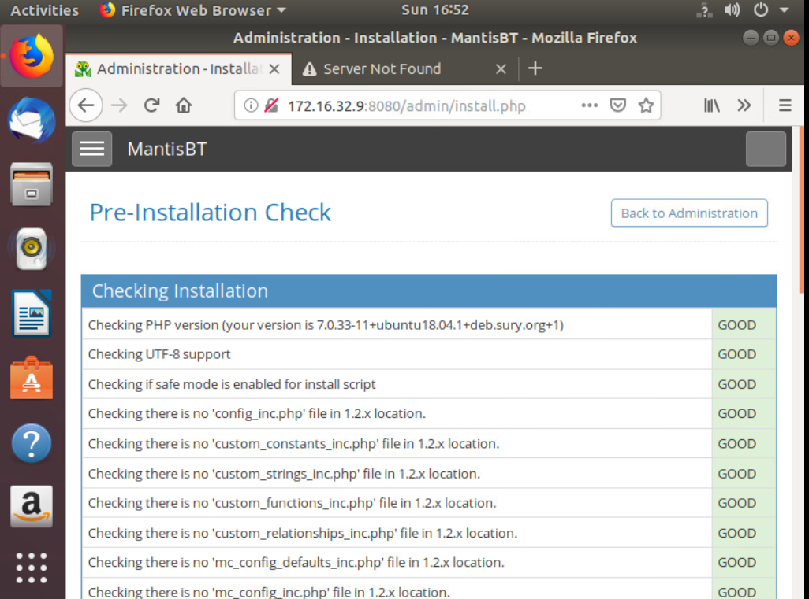

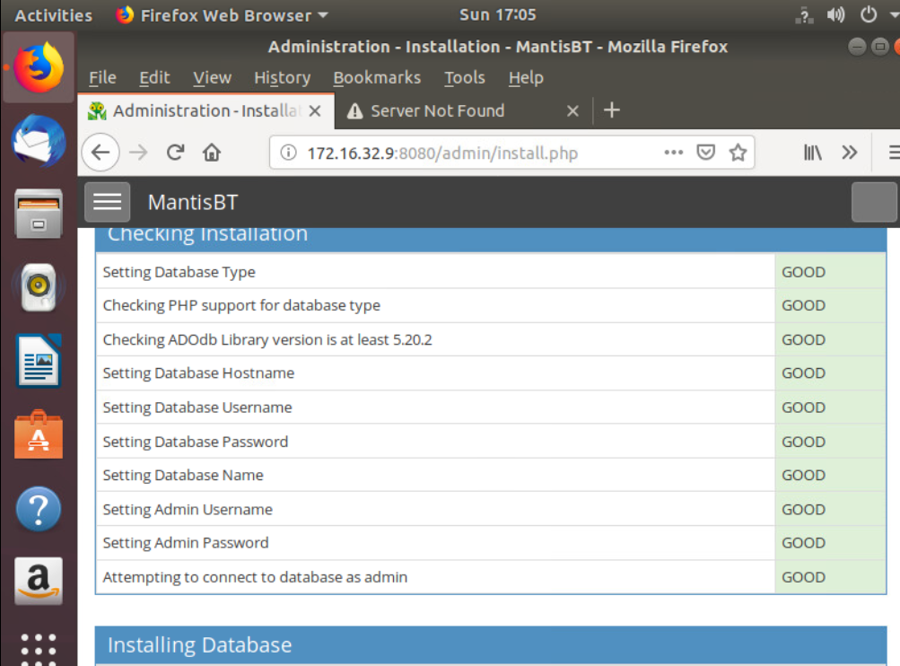

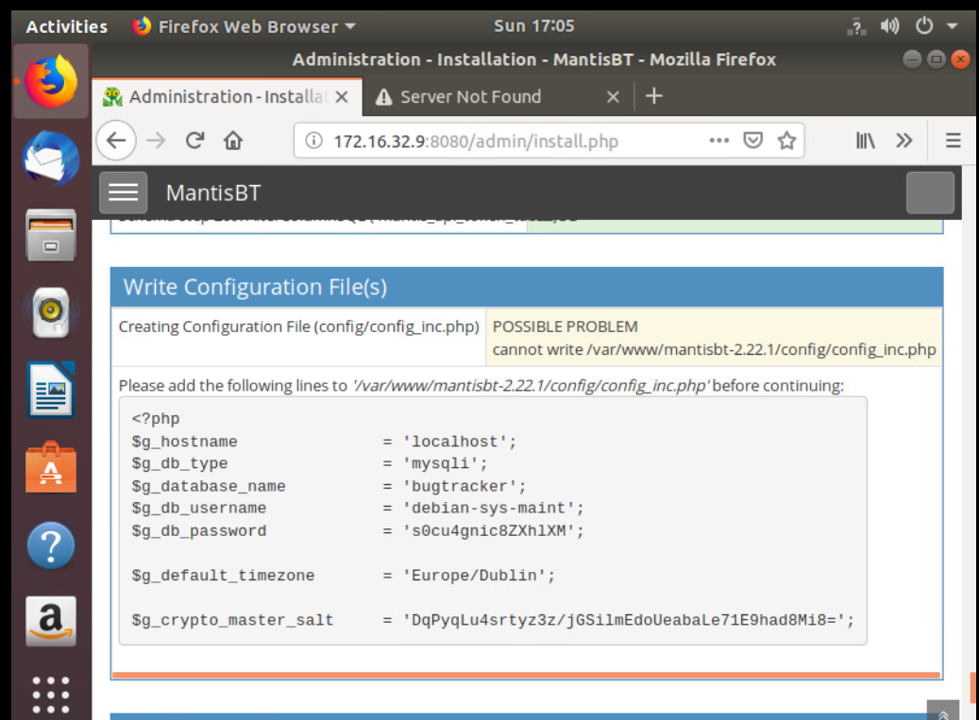

# Testing in Pilot-3 Testbed

1. Testing Kafka cluster

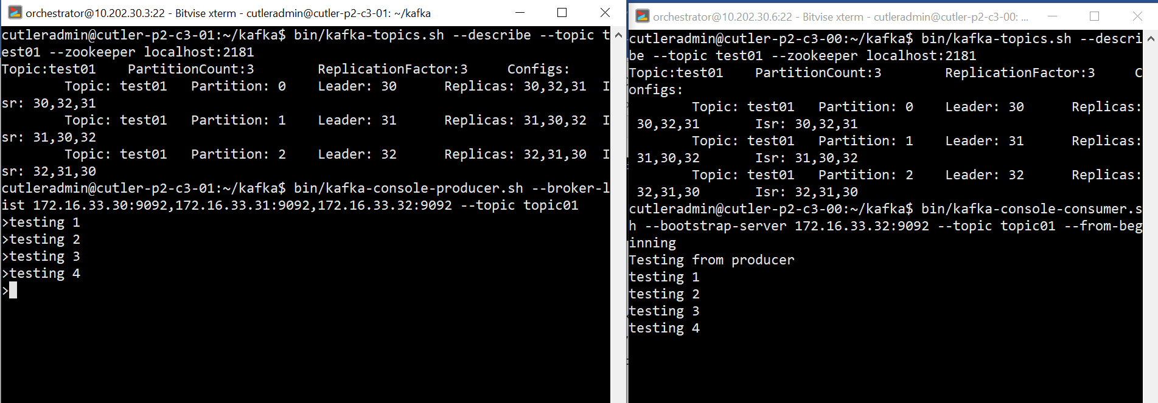

1. Testing ELB stack

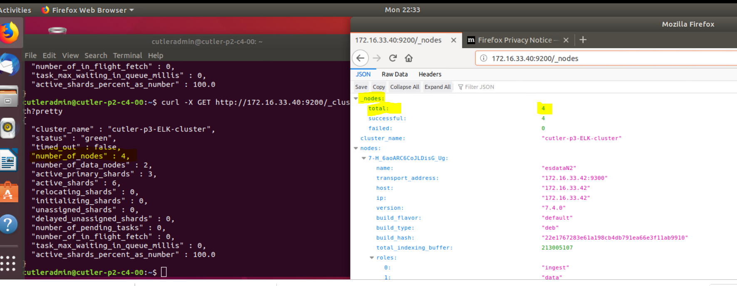

Test Apache2 on Elasticsearch master node:

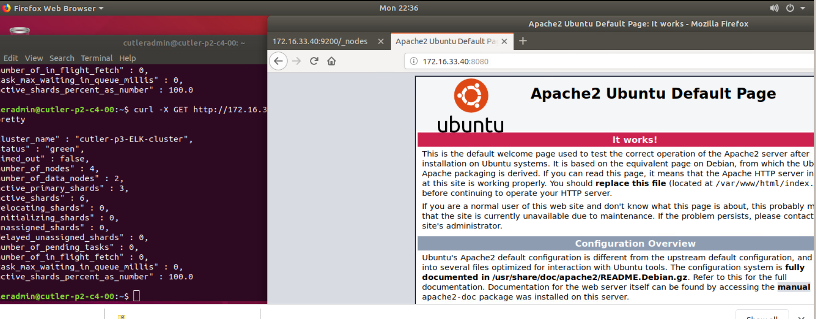

Testing Kibana:

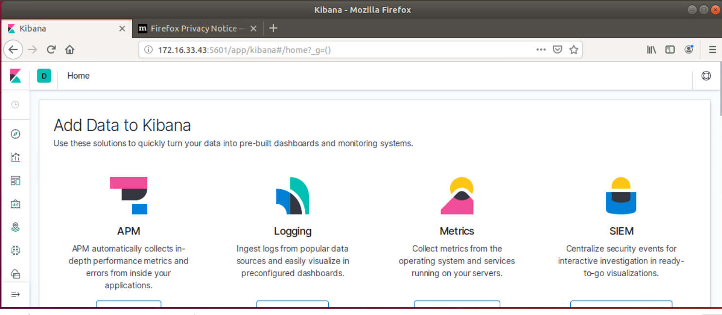

1. Testing Hadoop

start-yarn.sh

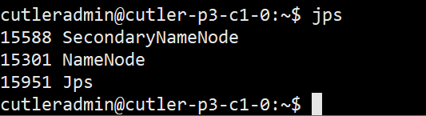

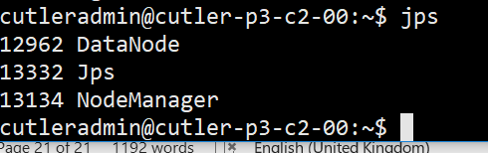

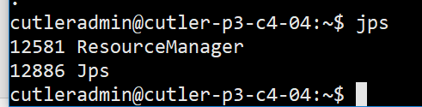

Submit a job:

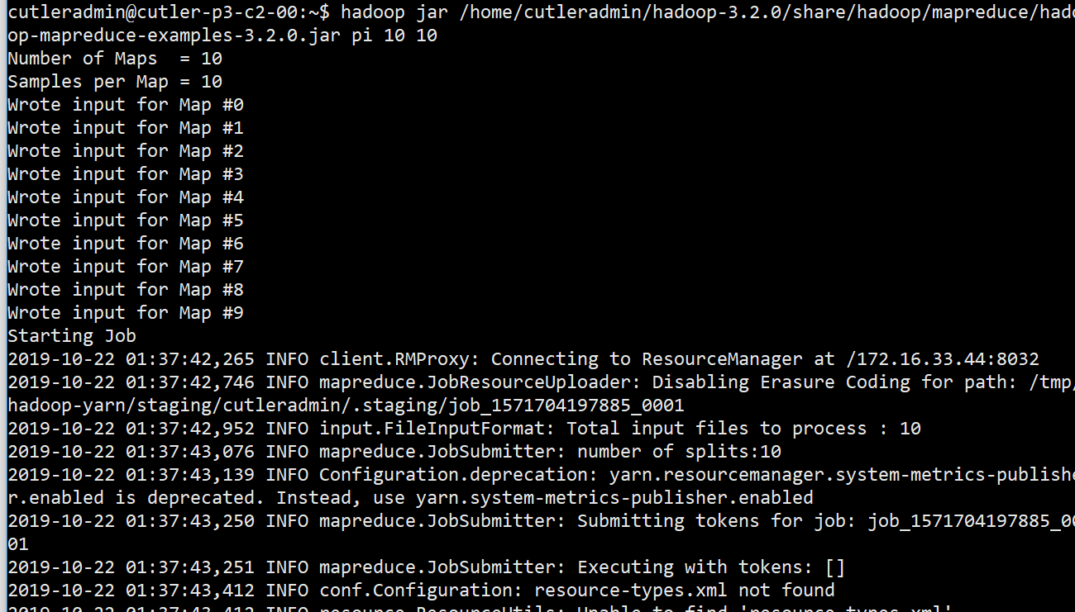

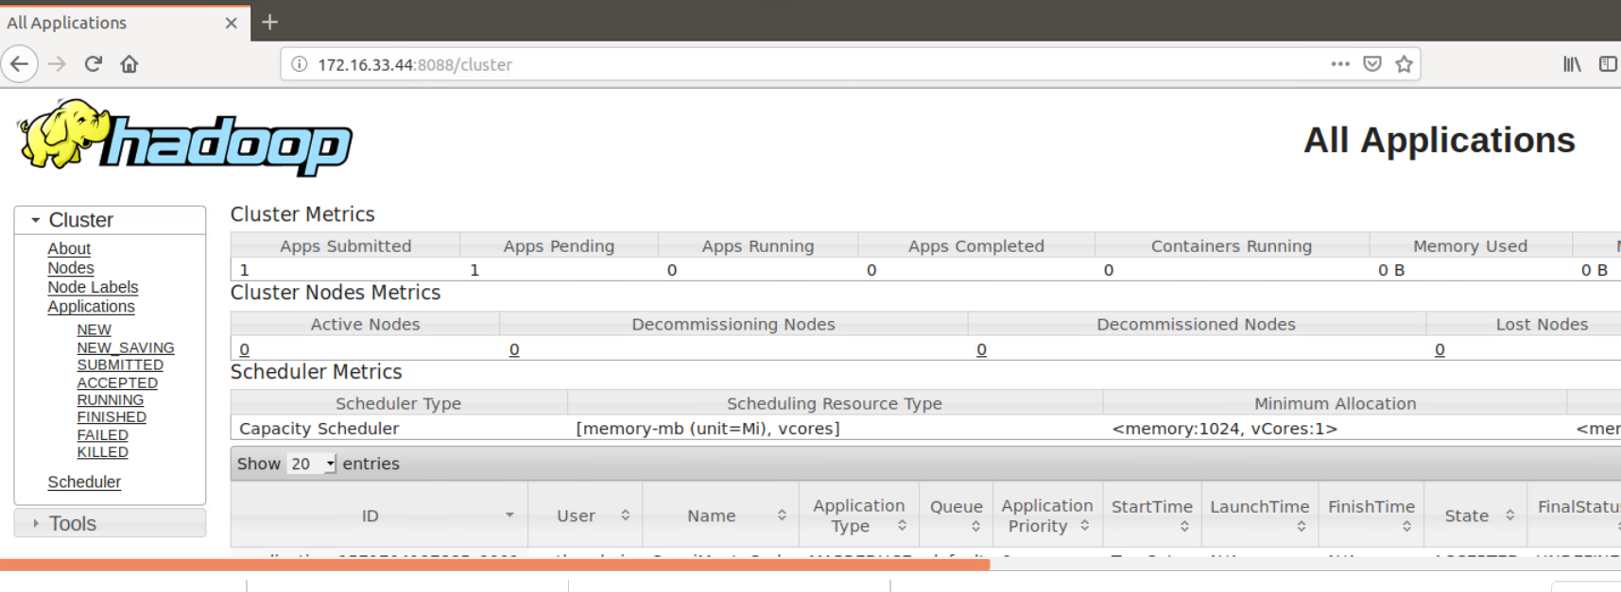

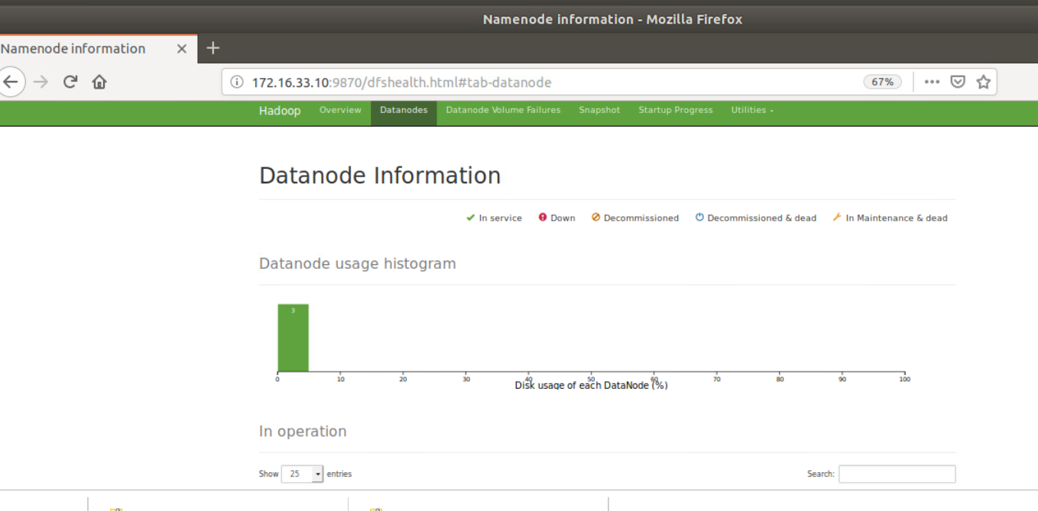

Testing Spark:

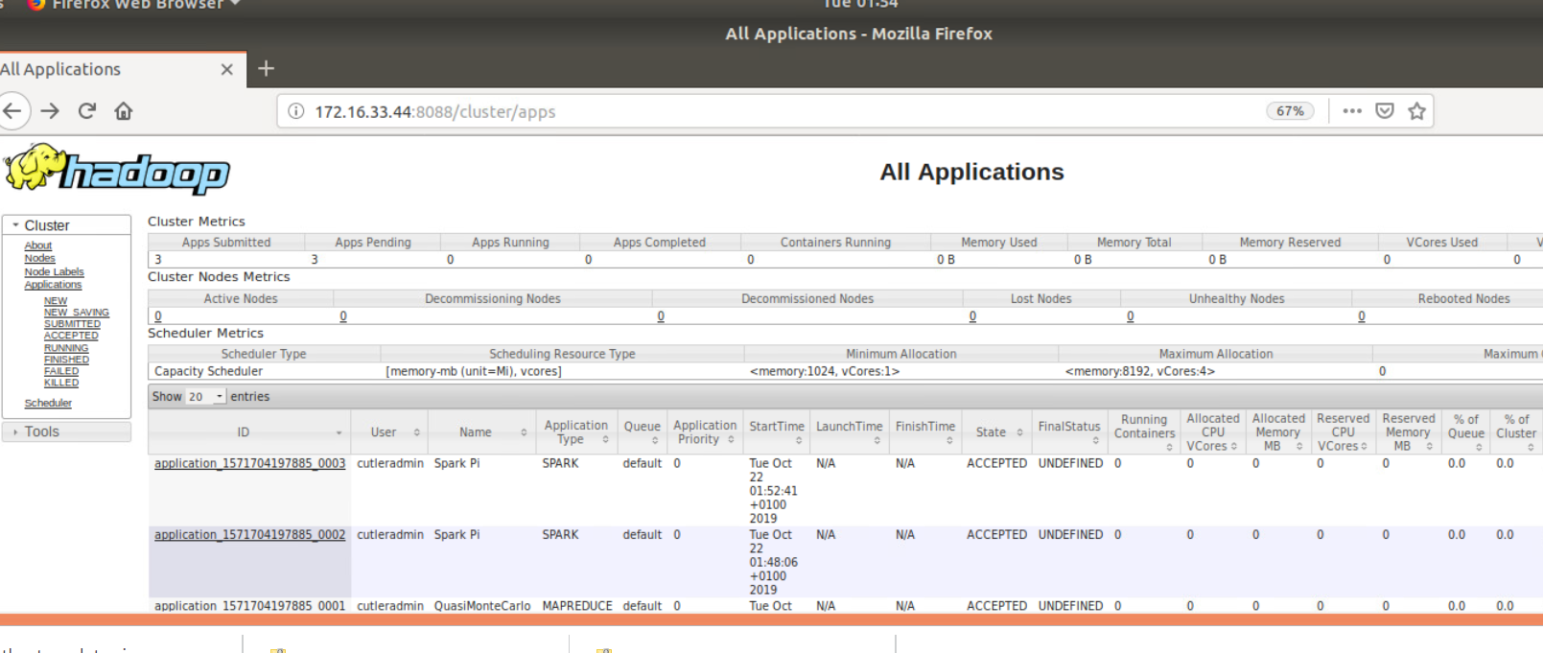

1. Testing Front-End server

Pilot-1 Testing

1. Kafka

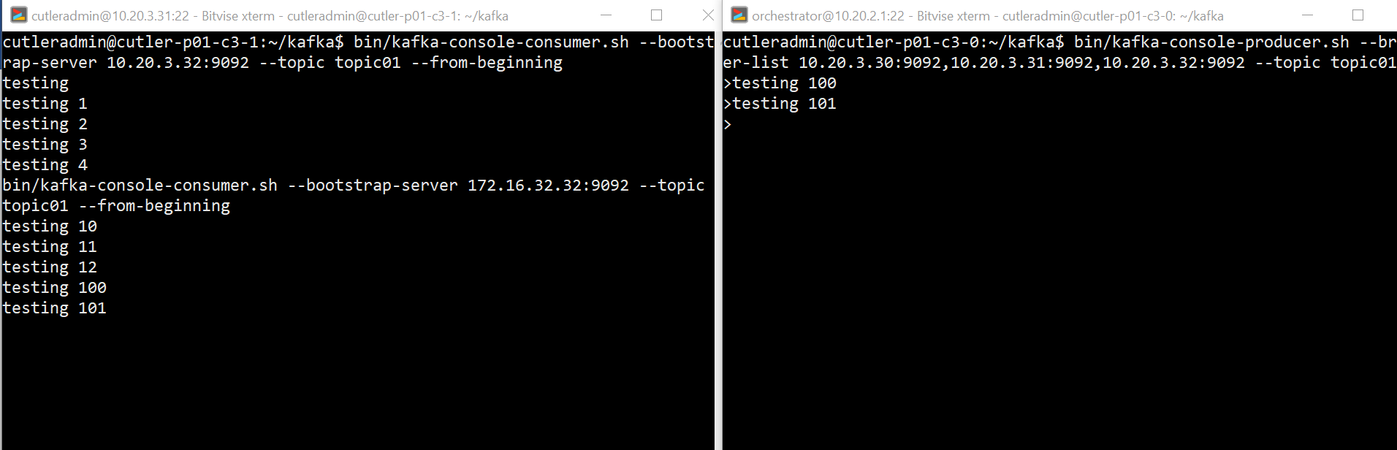

1. Elastic

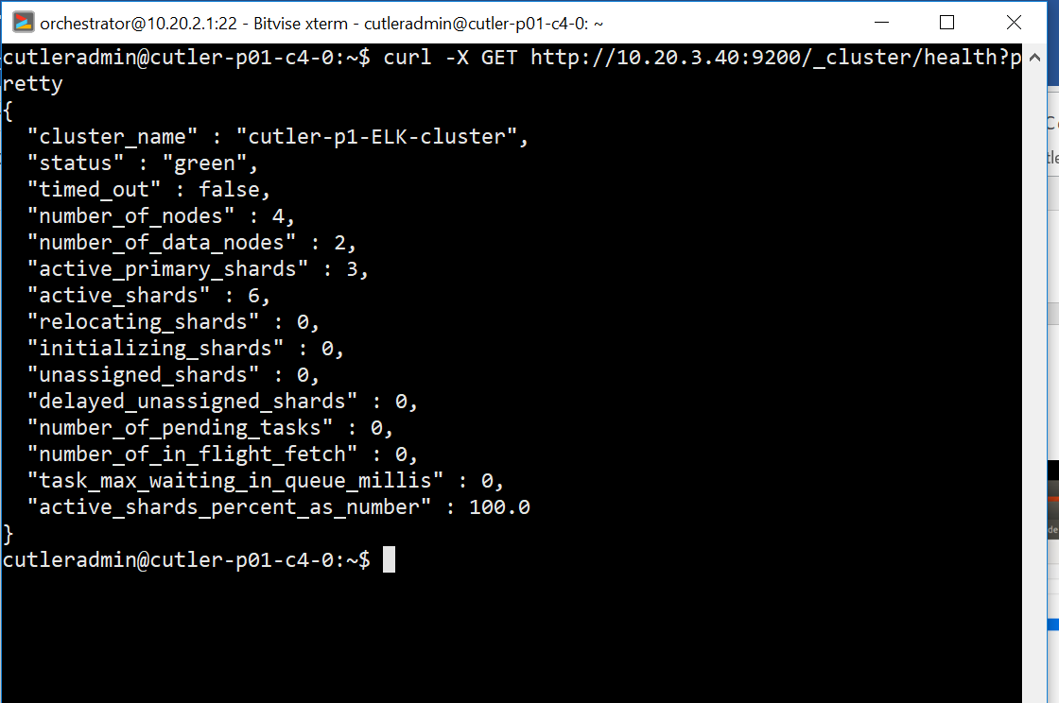

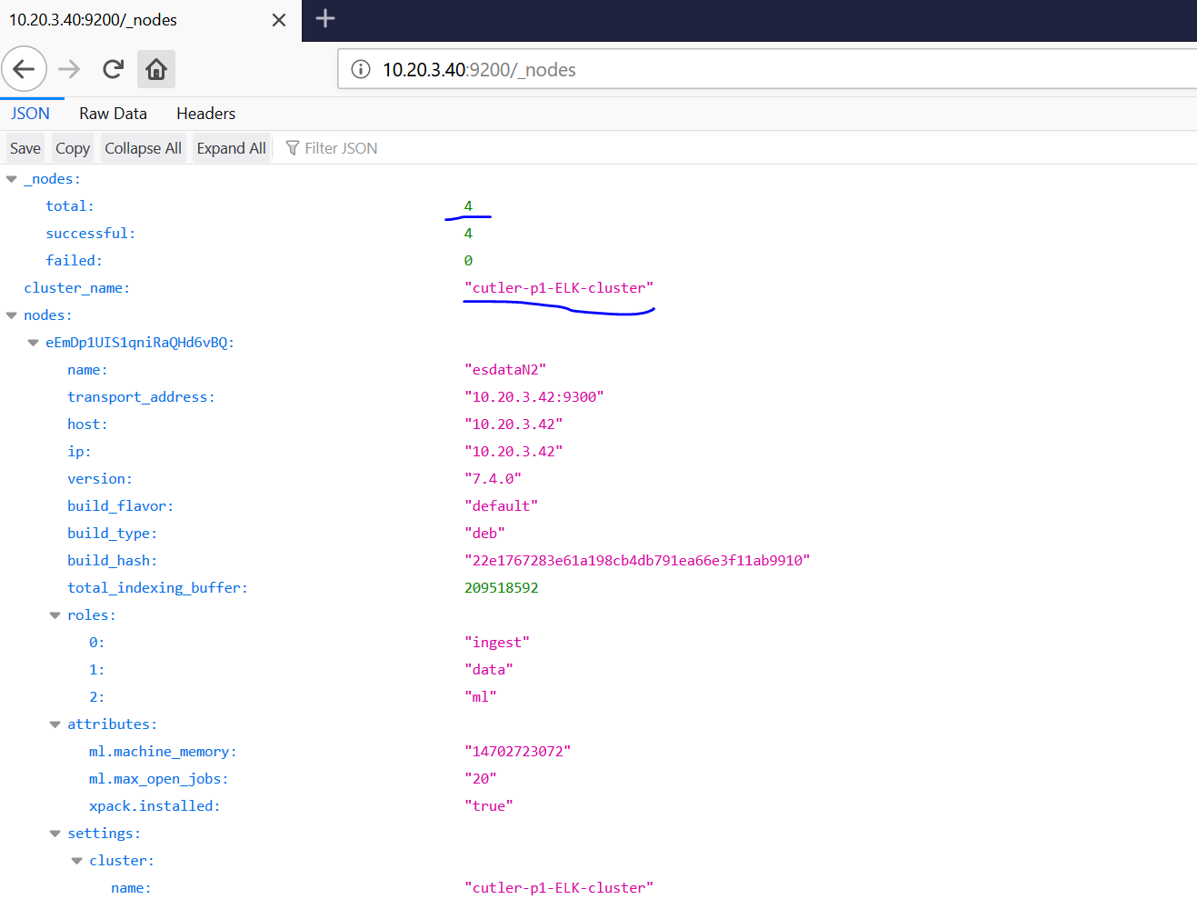

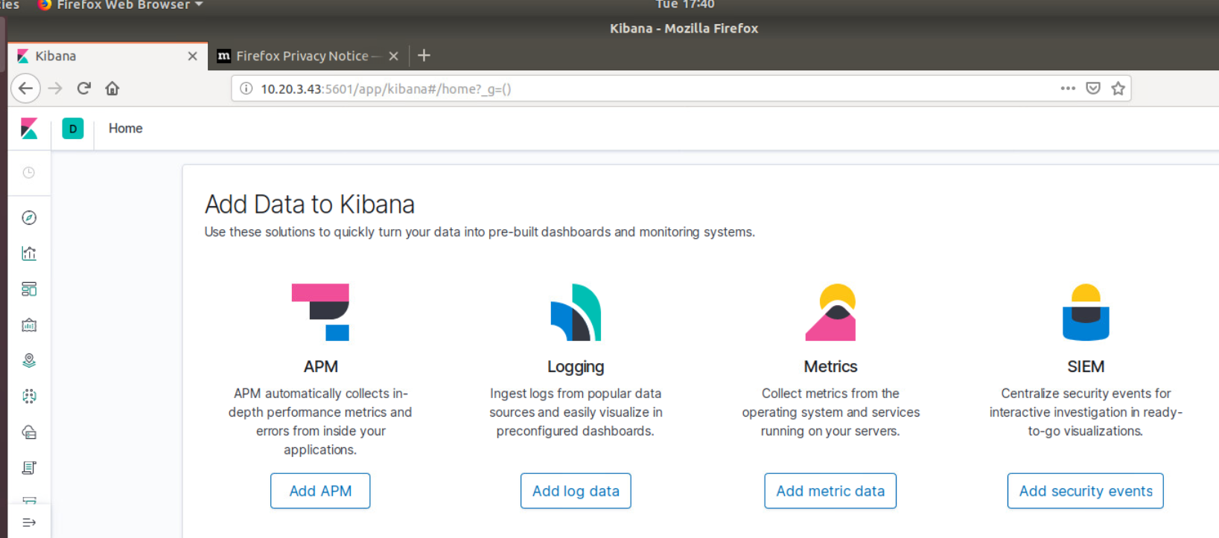

1. Hadoop

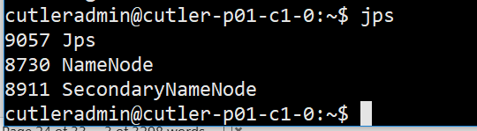

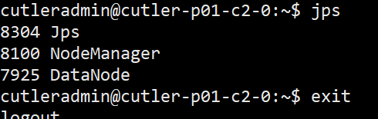

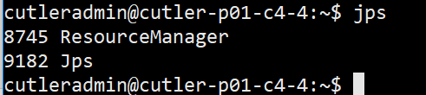

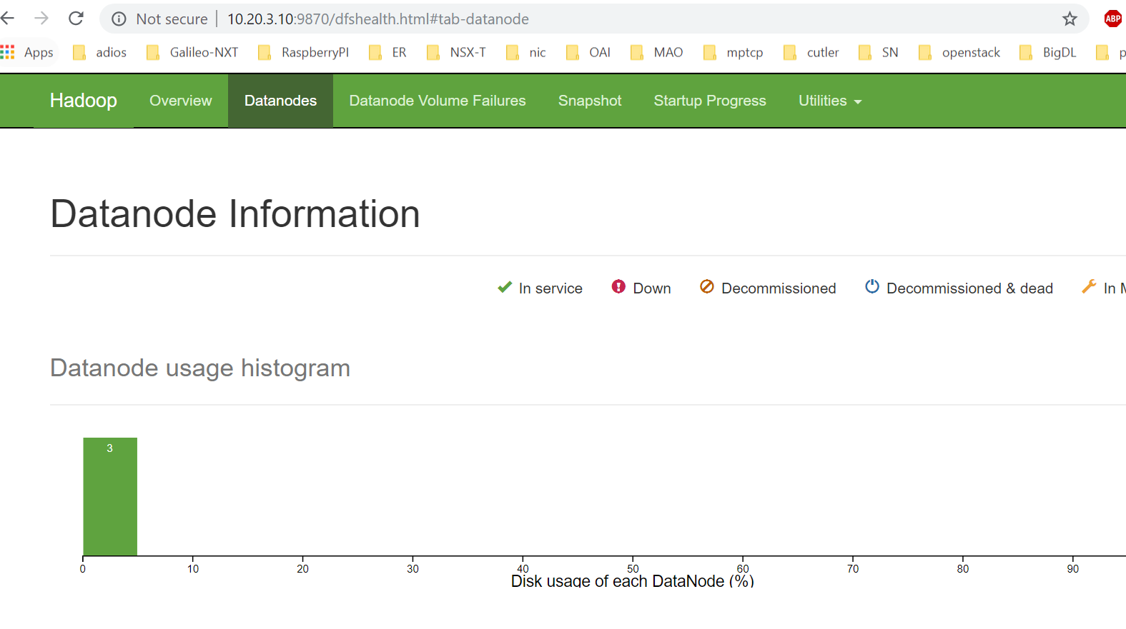

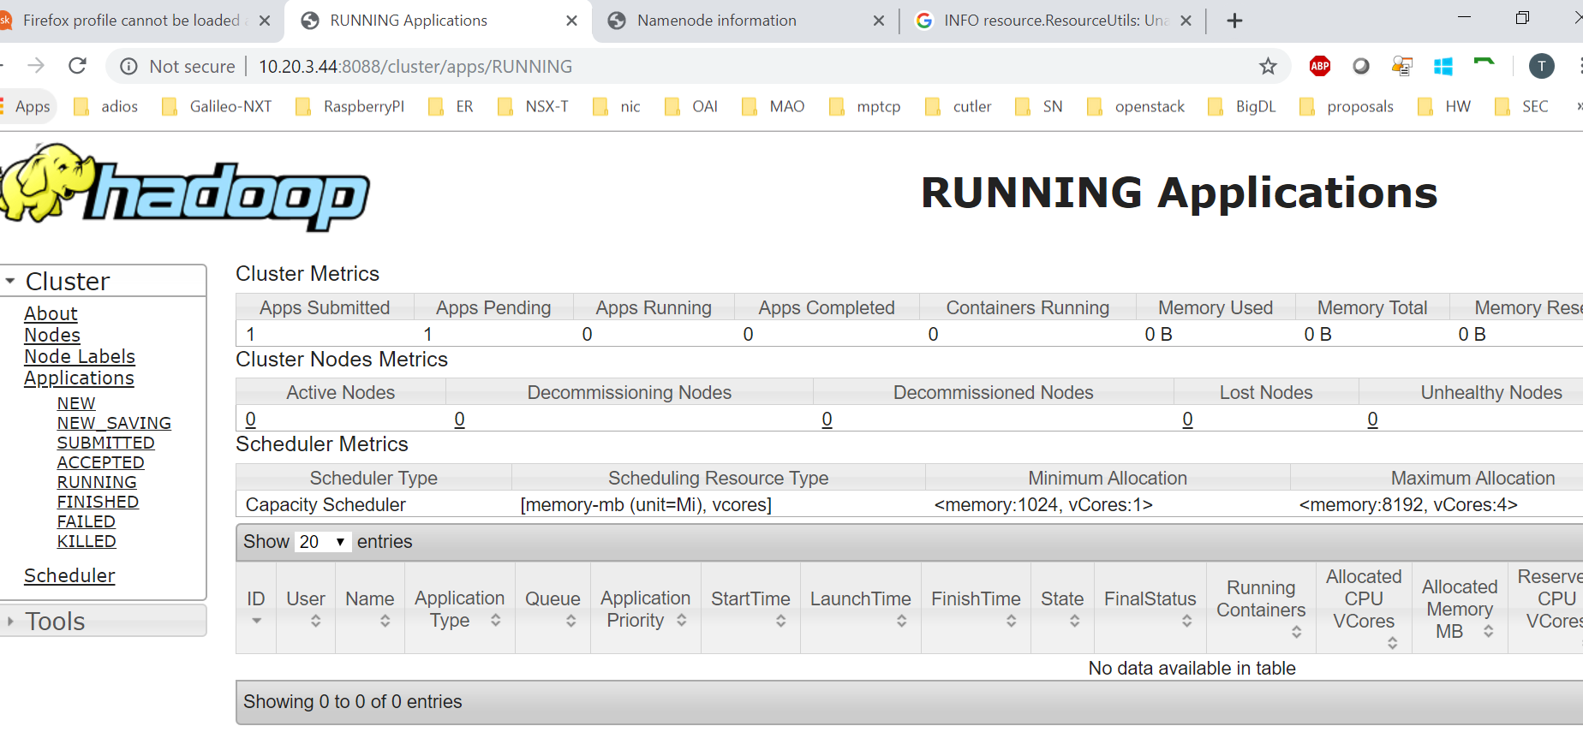

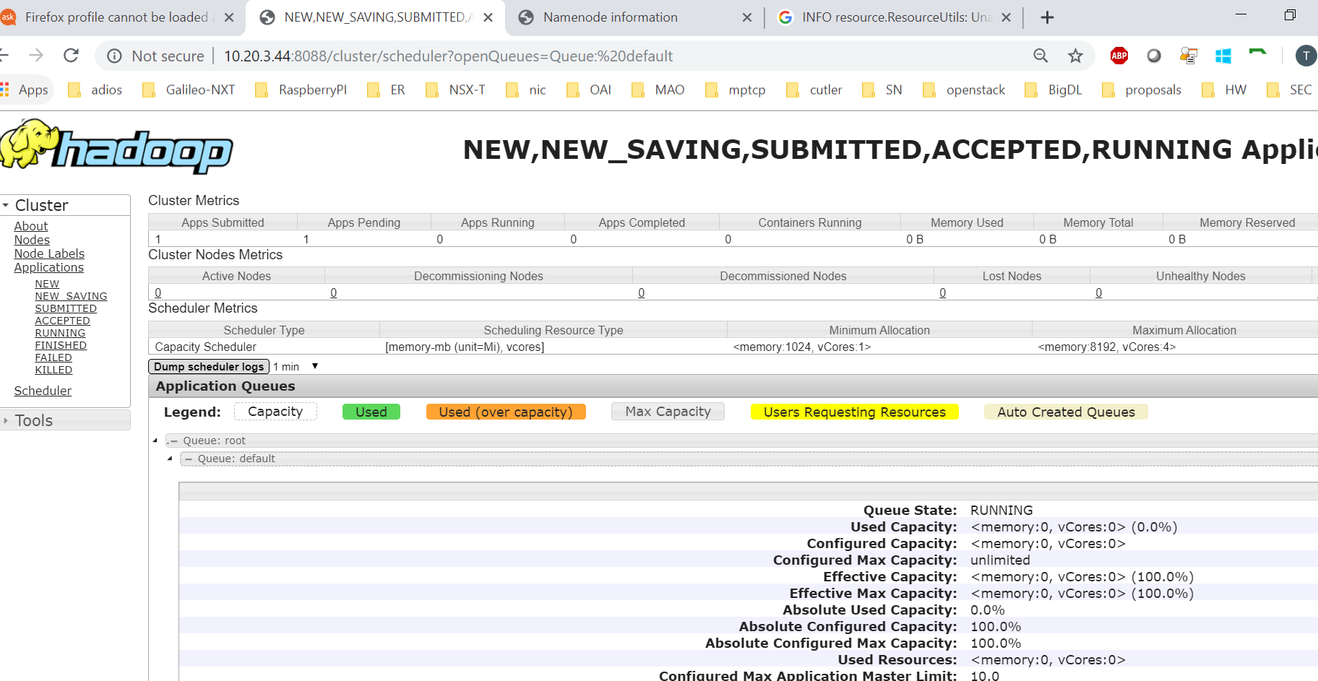

1. Spark

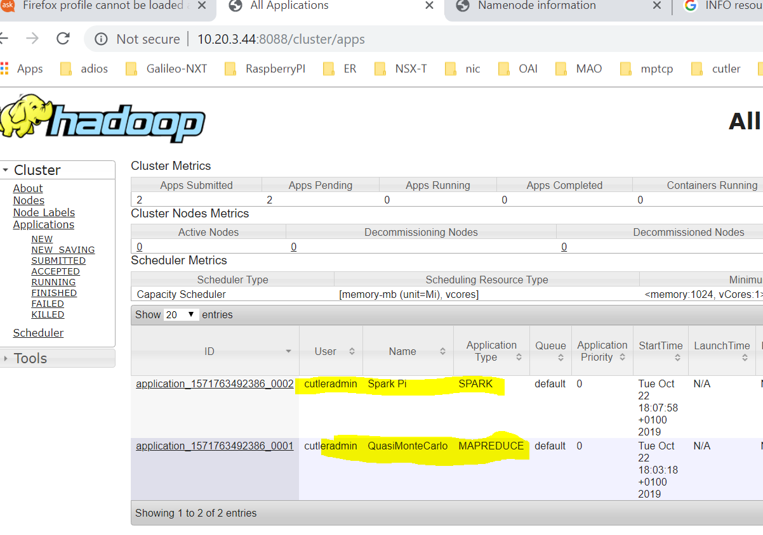

1. Front-end